Week 6 DS 775 Homework – Chris Austin

Submit your homework as a MS Word or PDF document this week. Solve the 4 problems below. In each case cut and paste the model and results into this document.

1. Problem 1 (7 pts) – use CP in OPL to solve textbook problem 12.9-2. This is very similar to one of the examples in the presentation this week. Paste your model and results here:

/*********************************************

* OPL 12.8.0.0 Model

* Author: caust

* Creation Date: Oct 5, 2018 at 6:07:16 PM

*

* maximize 5*x1 - x1^2 + 8x2 -x2^2 + 10x3 - x3^2 + 15x4 - x4^2 + 20x5 - x5^2

* with constraints:

* x1 through x5 are all different

* x1 + x3 + x5 <= 25

*

* x1 in {3,6,12}

* x2 in {3,6}

* x3 in {3,6,9,12}

* x4 in {6,12}

* x5 in {9,12,15,18}

*********************************************/

using CP;

int x[1..6] = [3,6,9,12,15,18];

dvar int p[1..5] in 1..6;

maximize 5*x[p[1]] - x[p[1]]^2 + 8*x[p[2]] - x[p[2]]^2 + 10*x[p[3]] - x[p[3]]^2 + 15*x[p[4]] - x[p[4]]^2 + 20*x[p[5]] - x[p[5]]^2;

subject to {

ct1:

allDifferent(p);

ct2: // constrain x1 = x[p[1]] to be in {3,6,12}

p[1] <=2 || p[1] == 4;

ct3: // constrain x2 = x[p[2]] to be in {3,6}

p[2]<=2;

ct4: // constrain x3 = x[p[3]] to be in {3,6,9,12}

p[3] <= 4;

ct5: // constrain x4 = x[p[4]] to be in {6,12}

p[4] == 2 || p[4] == 4;

ct6: // constrain x5 = x[p[5]] to be in {15,18}

p[5] >= 5;

ct7: // x1 + x3 + x4 <= 25

x[p[1]] + x[p[3]] + x[p[4]] <= 25 ;

}

execute{

writeln('x1 is ',x[p[1]]);

writeln('x2 is ',x[p[2]]);

writeln('x3 is ',x[p[3]]);

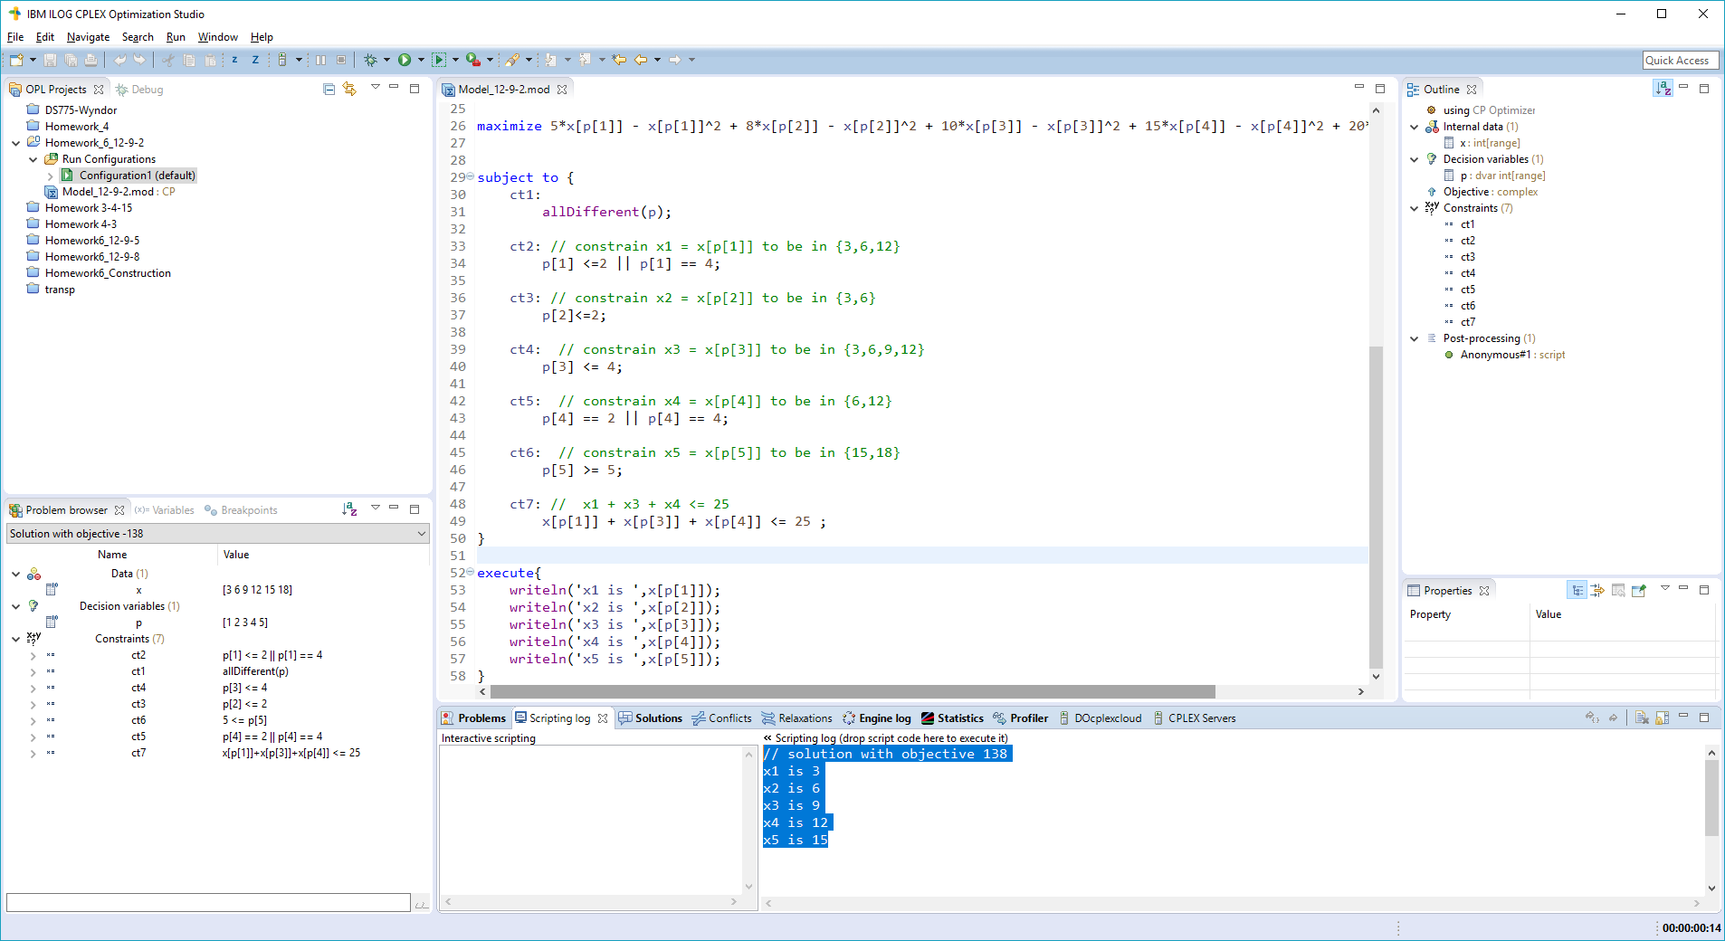 writeln('x4 is ',x[p[4]]);

writeln('x5 is ',x[p[5]]);

}

// solution with objective 138

x1 is 3

x2 is 6

x3 is 9

x4 is 12

x5 is 15

1. Problem 2 (8 pts) – use CP in OPL to solve textbook problem 12.9-5. You’ll need to create a “dummy” race as a place to assign the fifth swimmer. Paste your model and results here:

/*********************************************

* OPL 12.8.0.0 Model

* Author: Chris Austin

* Creation Date: Oct 6, 2018 at 5:11:10 PM

*********************************************/

using CP;

range R = 1..5;

range Q = 1..4;

string name[R] = ["Carl", "Chris", "David", "Tony", "Ken"];

// racers and ability to compete. The four swimmers that make the team will end up with a '1'

dvar int x[R] in 1..5;

// Race times

// Backstroke

float z1[R] = [37.7,32.9,33.8,37.0,35.4];

// Breaststroke

float z2[R] = [43.4,33.1,42.2,34.7,41.8];

// Butterfly

float z3[R] = [33.3,28.5,38.9,30.4,33.6];

// Freestyle

float z4[R] = [29.2, 26.4, 29.6, 28.5, 31.1];

// Dummy

float z5[R] = [0,0,0,0,0];

// Minimize total race sums over the best 4 racers and races. q ranges from 1 to 4.

// All-different constraint along with zero costs force the fifth racer to the dummy race.

minimize sum(q in Q) z1[x[q]] +

sum(q in Q) z2[x[q]] +

sum(q in Q) z3[x[q]] +

sum(q in Q) z4[x[q]] + z5[x[5]];

// only 4 of the 5 racers fastest over all 4 race types can make the team.

subject to {

allDifferent(x);

}

execute{

writeln(name[x[1]], " made the swim team.")

writeln(name[x[2]], " made the swim team.")

writeln(name[x[3]], " made the swim team.")

writeln(name[x[4]], " made the swim team.")

writeln(name[x[5]], " did not make the swim team.")

writeln("\nMinimum Backstroke time: ", z1[x[1]] + z1[x[2]] + z1[x[3]] + z1[x[4]])

writeln("Minimum Breaststroke time: ", z2[x[1]] + z2[x[2]] + z2[x[3]] + z2[x[4]])

writeln("Minimum Butterfly time: ", z3[x[1]] + z3[x[2]] + z3[x[3]] + z3[x[4]])

writeln("Minimum Freestyle time: ", z4[x[1]] + z4[x[2]] + z4[x[3]] + z4[x[4]])

}

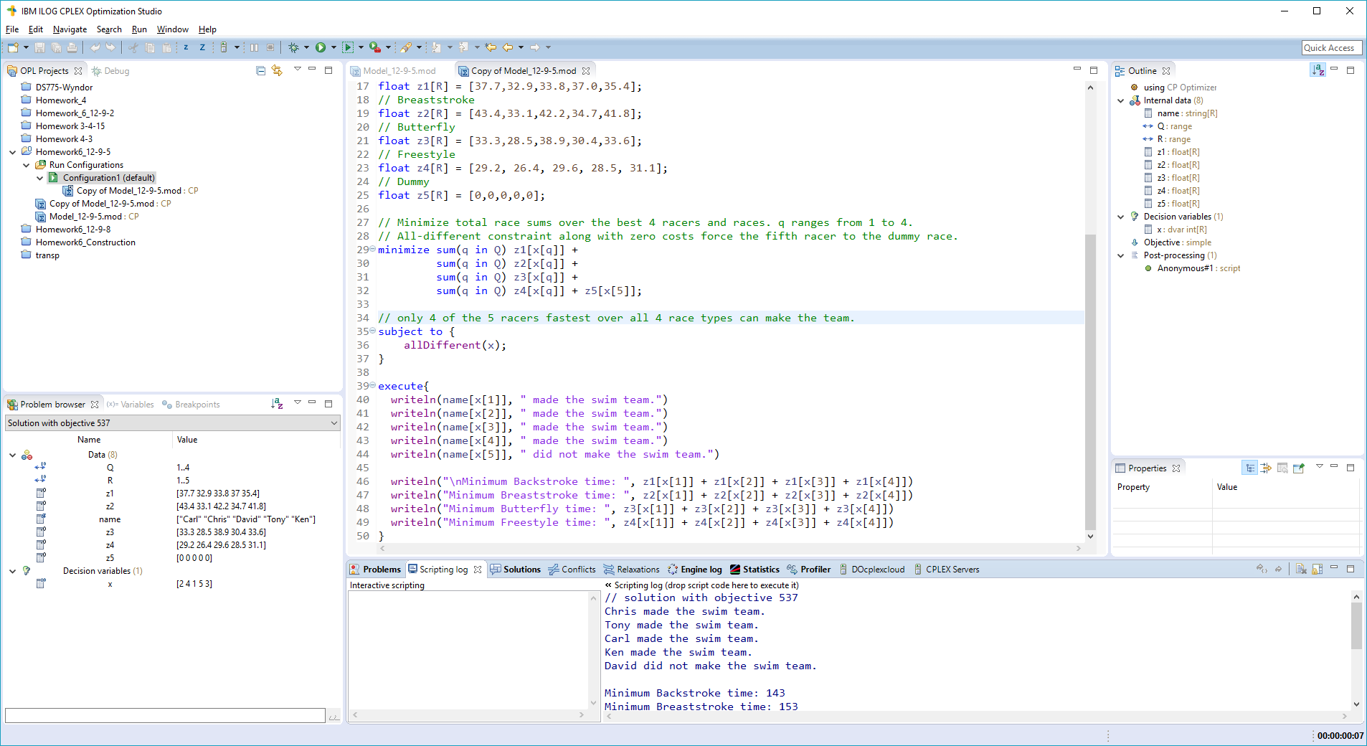// solution with objective 537

Chris made the swim team.

Tony made the swim team.

Carl made the swim team.

Ken made the swim team.

David did not make the swim team.

Minimum Backstroke time: 143

Minimum Breaststroke time: 153

Minimum Butterfly time: 125.8

Minimum Freestyle time: 115.2

1. Problem 3 (7 pts) – solve the Traveling Salesman Problem using CP as discussed in the presentation and in problem 12-9.8. Write a CP program in OPL to solve the TSP introduced on page 621 of your book. You can start with the file tsp_cp_skeleton.mod in the download packet. The model file includes the cost matrix associated with the graph in figure 14.4. Note that we are using a very large value of $M$ as the cost between cities which are not connected to prevent the solution from using those connections. Paste your model and results here:

/*********************************************

* OPL 12.8.0.0 Model

* Author: Chris Austin

* Creation Date: Oct 7, 2018 at 10:28:02 AM

*********************************************/

using CP;

int n = 7;

int M = 1000;

int c[1..n][1..n] =

[ [ 0, 12, 10, M, M, M, 12],

[12, 0, 8, 12, M, M, M],

[10, 8, 0, 11, 3, M, 9],

[ M, 12, 11, 0, 11, 10, M],

[ M, M, 3, 11, 0, 6, 7],

[ M, M, M, 10, 6, 0, 9],

[12, M, 9, M, 7, 9, 0]];

range R = 2..n;

dvar int x[R] in R;

minimize c[1][x[2]] + c[x[2]][x[3]] + c[x[3]][x[4]] + c[x[4]][x[5]] + c[x[5]][x[6]] +

c[x[6]][x[7]] + c[x[7]][1];

subject to {

allDifferent(x);

}

execute {

writeln("Shortest path is: 1-",x[2],"-",x[3],"-",x[4],"-",x[5],"-",x[6],"-",x[7],"-1")

}

// solution with objective 63

Shortest path is: 1-3-5-7-6-4-2-1

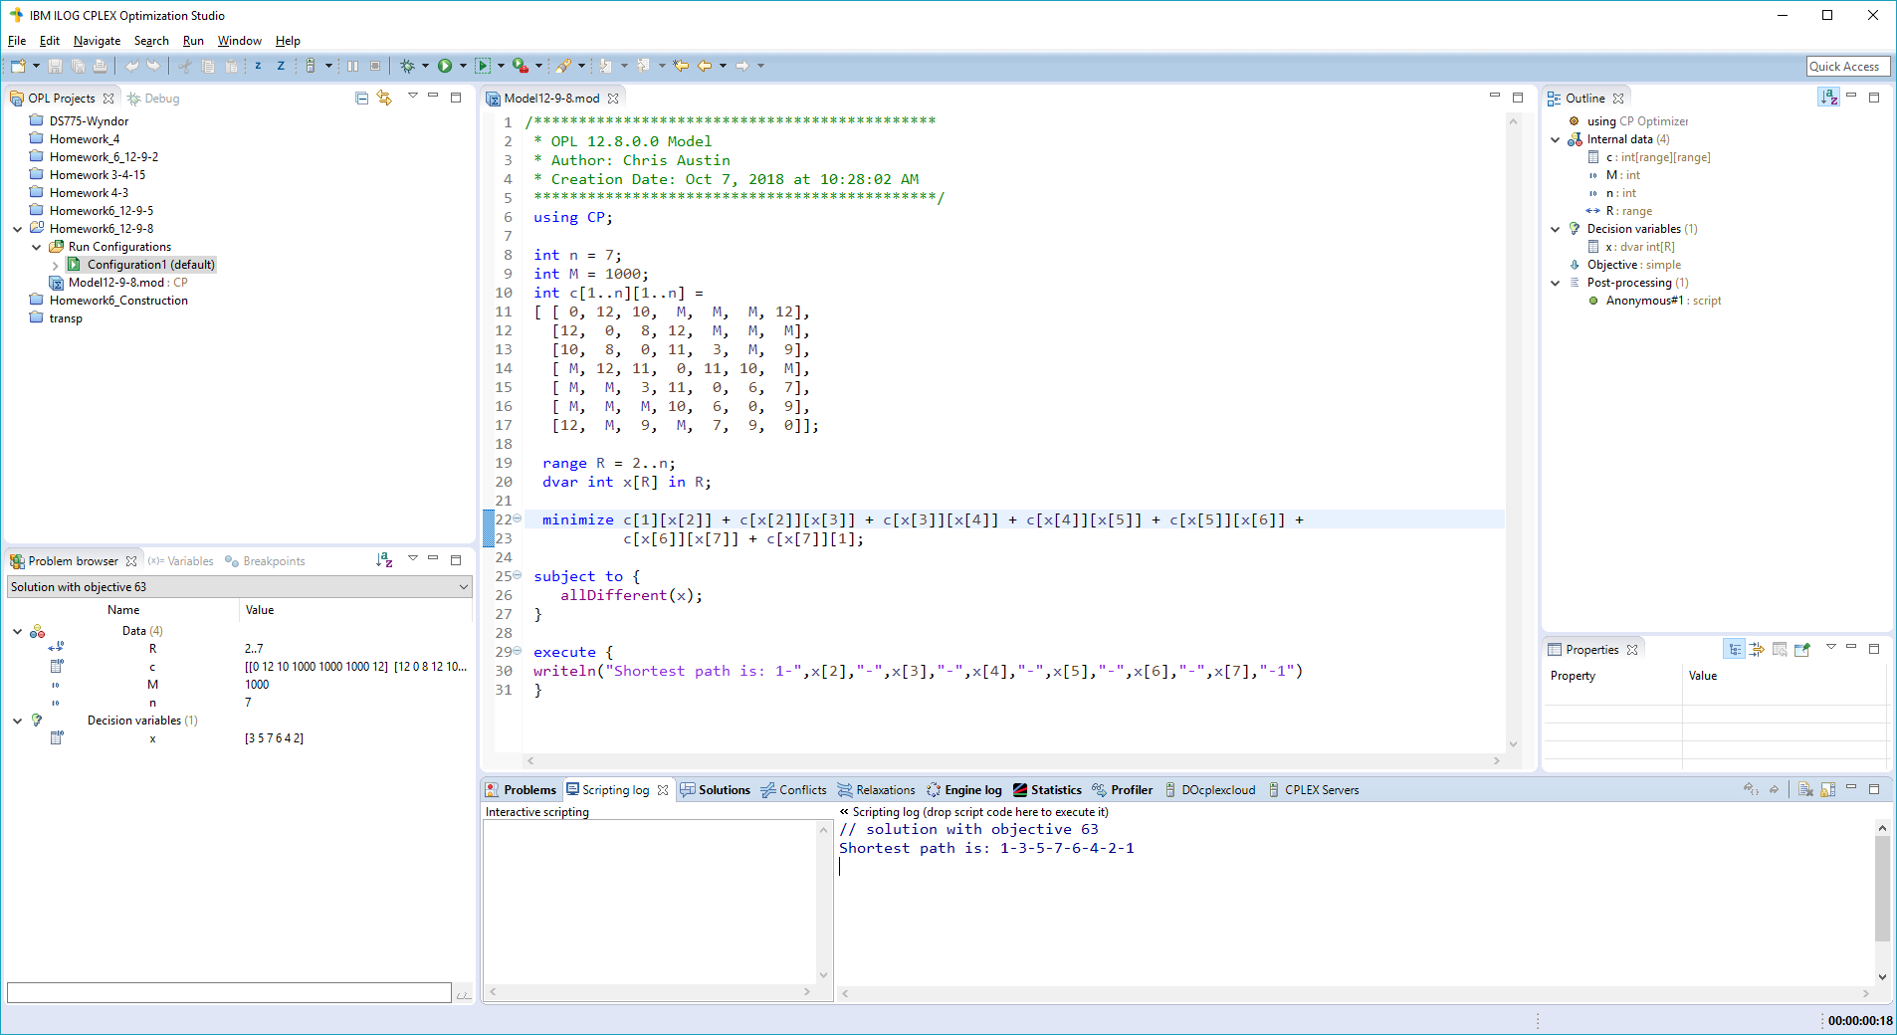

1. Problem 4 (8 pts) – use CP in OPL to solve the Reliable Construction Company construction scheduling problem described in the supplemental textbook section 22.1 (in download packet). You’ll want to study the example sched_intro.mod that is included with OPL (File -> New -> Example …) which is also in the download packet for convenience (we deleted some stuff in the version in the download packet for simplicity). Paste your model and results here:

/*********************************************

* OPL 12.8.0.0 Model

* Author: Chris Austin

* Creation Date: Oct 7, 2018 at 12:10:31 PM

*********************************************/

using CP;

dvar interval excavate size 2;

dvar interval foundation size 4;

dvar interval roughWall size 10;

dvar interval roof size 6;

dvar interval extPlumbing size 4;

dvar interval intPlumbing size 5;

dvar interval siding size 7;

dvar interval extPainting size 9;

dvar interval electrical size 7;

dvar interval wallBoard size 8;

dvar interval flooring size 4;

dvar interval intPaint size 5;

dvar interval extFixture size 2;

dvar interval intFixture size 6;

subject to {

endBeforeStart(excavate, foundation);

endBeforeStart(foundation, roughWall);

endBeforeStart(roughWall, roof);

endBeforeStart(roughWall, extPlumbing);

endBeforeStart(extPlumbing, intPlumbing);

endBeforeStart(roof, siding);

endBeforeStart(extPlumbing, extPainting);

endBeforeStart(siding, extPainting);

endBeforeStart(roughWall, electrical);

endBeforeStart(intPlumbing, wallBoard);

endBeforeStart(electrical, wallBoard);

endBeforeStart(wallBoard, flooring);

endBeforeStart(wallBoard, intPaint);

endBeforeStart(extPainting, extFixture);

endBeforeStart(flooring, intFixture);

endBeforeStart(intPaint, intFixture);

}

execute {

writeln("Excavate : " + excavate.start + ".." + excavate.end);

writeln("Foundation : " + foundation.start + ".." + foundation.end);

writeln("Rough Wall : " + roughWall.start + ".." + roughWall.end);

writeln("Roof : " + roof.start + ".." + roof.end);

writeln("Ext. Plumbing : " + extPlumbing.start + ".." + extPlumbing.end);

writeln("Int. Plumbing : " + intPlumbing.start + ".." + intPlumbing.end);

writeln("Siding : " + siding.start + ".." + siding.end);

writeln("Ext. Painting : " + extPainting.start + ".." + extPainting.end);

writeln("Electrical : " + electrical.start + ".." + electrical.end);

writeln("Wall Board : " + wallBoard.start + ".." + wallBoard.end);

writeln("Flooring : " + flooring.start + ".." + flooring.end);

writeln("Int. Paint : " + intPaint.start + ".." + intPaint.end);

writeln("Ext. Fixture : " + extFixture.start + ".." + extFixture.end);

writeln("Int. Fixture : " + intFixture.start + ".." + intFixture.end);

}

// solution

Excavate : 0..2

Foundation : 2..6

Rough Wall : 6..16

Roof : 16..22

Ext. Plumbing : 16..20

Int. Plumbing : 20..25

Siding : 22..29

Ext. Painting : 29..38

Electrical : 16..23

Wall Board : 25..33

Flooring : 33..37

Int. Paint : 33..38

Ext. Fixture : 38..40

Int. Fixture : 38..44

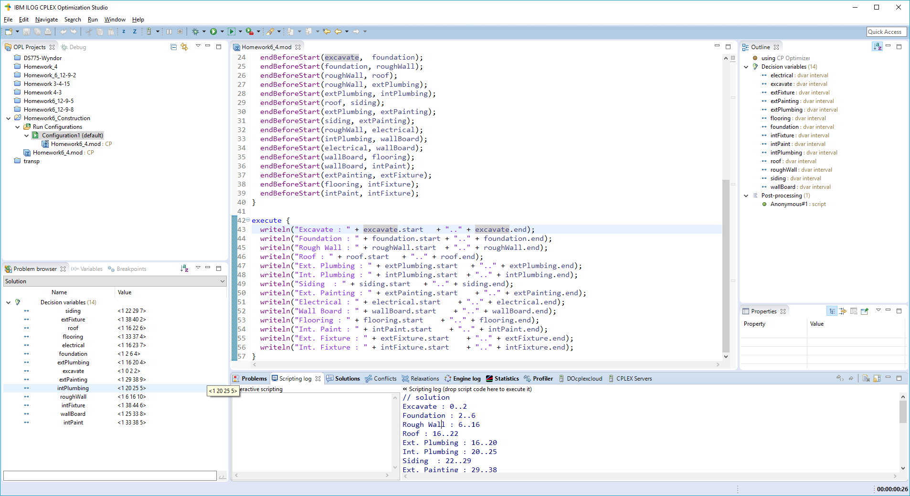

44 weeks looks to be the scheduled duration for the project.